1. Differences between Gouraud shading and Phong shading models.

Answer: The differences between the two shading models is mainly the fact that the Gouraud model shades the object at the vertices while the Phong model shades the based on the normal vector for each vertex and each vector. Phong shading is more efficient (according to the text), given that it requires the lighting model to be applied to each fragment in the object. Gouraud shading also depends on the object’s distance to both the light source as well as the viewer, if the object is too far away then the object will be one solid color and not look realistic at all! Lastly, Gouraud shading seems to only rely (mathematically) on averaging the normal vectors at points were polygons intersect, Phong shading however requires finding the normal vectors for each vertex along each edge and then finding the normal vectors for each interior point as well!

Using the image from the other part of this assignment, we see that the Gouraud shading model (in this case) displays the object as follows:

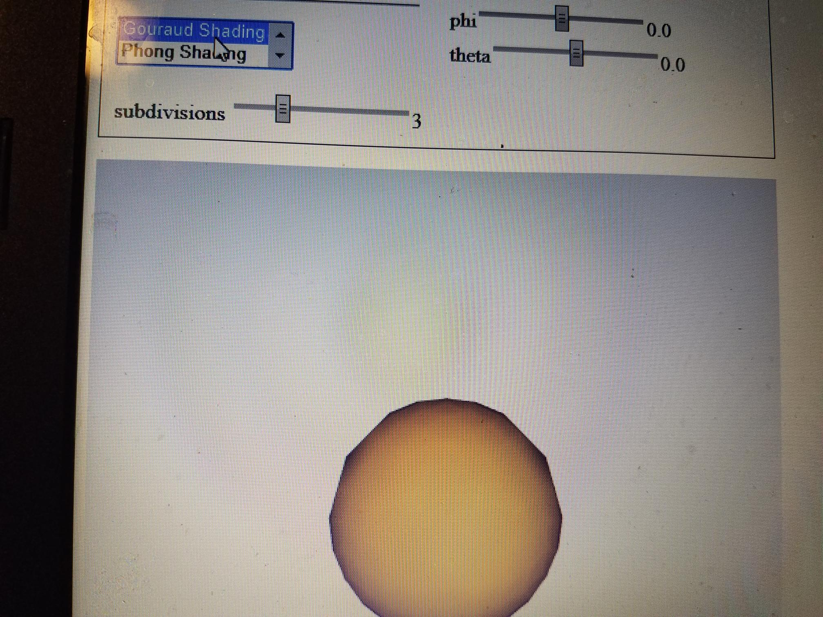

Using the image from the other part of this assignment, we see that the Phong shading model (in this case) displays the object as follows:

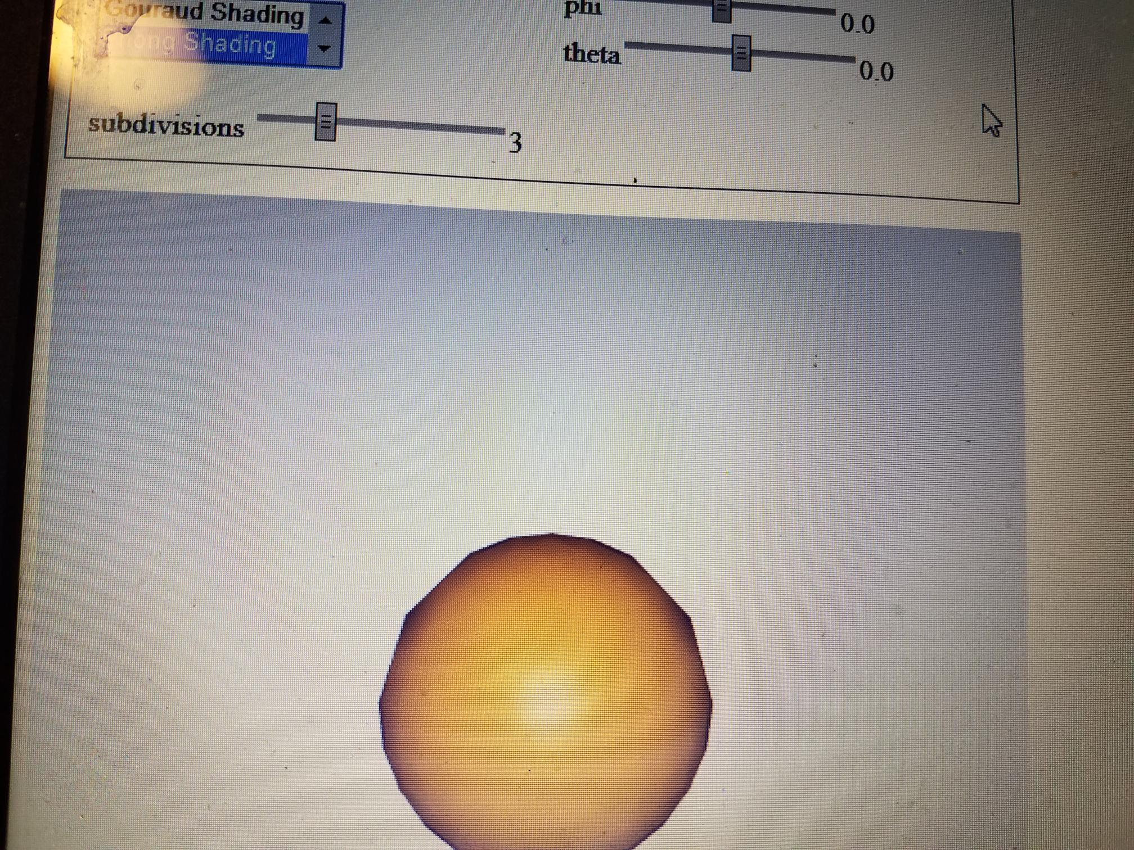

1. Non-physical (non-realistic) components in the Phong reflection model.

Answer: The Phong reflection model uses 3 separate components for each ambient, diffuse, and specular term. This is a non-physical component that is used in an attempt to create more realistic shading effects. The only other non-physical component in the Phong reflection model that I could find was that it uses separate terms for ambient light, diffuse light, and specular light. This is done in order to make the lighting upon the object look like the object has three dimensional properties even though the object is only two dimensional.